**Provisioning a Vagrant file!**

This means executing your commands or scripts when your vm comes up:

* Open your Vagrant file with Notepad++
* Head to line 66 – 69 (Edit according to the vm box (centos or Ubuntu command-line) )
* Add the commands you which to execute to automate your tasks.

Example of the command-lines using Centos7

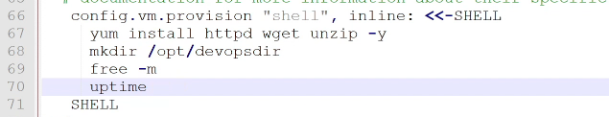

* Vagrant reload –provision (to apply the changes )

Example of the command-lines using Ubuntu

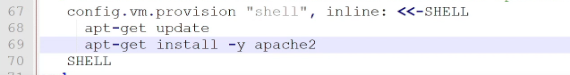

* Vagrant reload –provision (to apply the changes )

Next study area: Check Multiple Vagrant file! (multi(Vagrant file!)